Sincerity, Nobility and Service
CLASS: XI A CHEMISTRY
DATE: 27.01.19
- Write IUPAC names of the following compounds:
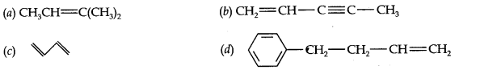
- Propanal and pentan-3-one are the ozonolysis products of an alkene. What is the structural formula of the alkene?
- Draw the cis- and trans-structures for hex-2-ene. Which iosmer will have higher b.pt. and why?
- Explain why alkyl groups act as electron donors when attached to a π-system.
- Draw the resonance structures for the following compounds. Show the electron shift using curved-arrow notation. (a) C₆H₅OH (b)CH₃CH=CHCH₂
- What is the relationship between the members of following pairs of structures? Are they structural or geometrical isomers or resonance contributors?
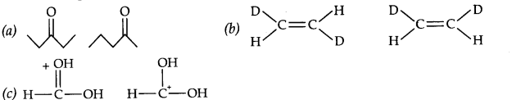

- Balance the following redox reactions by ion-electron method.
(a) MnO₄–(aq) +I–(aq) ———>Mn0₂(s) + I₂ (s) (in basic medium)
- Depict the galvanic cell in which the reaction, Zn(s) + 2Ag⁺(aq) —> Zn²⁺(aq) + 2Ag(s)
takes place. Further show:
(i) Which of the electrode is negatively charged.
(ii) The carriers of current in the cell
- Identify the substance oxidised, reduced, oxidising agent and reducing agent for each of the following reactions.
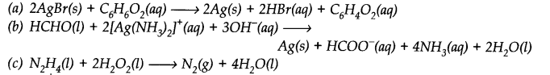
- Arrange benzene, n-hexane and ethyne in decreasing order of acidic behaviour. Also give reason for this behaviour.
- Why is benzene extra-ordinarily stable though it contains three double bonds?
- What are the necessary conditions for any system to be aromatic?
- For the following bond cleavages, use curved-arrows to show the electron flow and classify each as homolysis or heterolysis. Identify reactive intermediate produced as free radical, carbocation and carbanion.
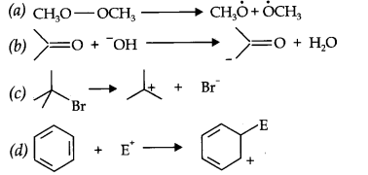
- Justify that the following reactions are redox reactions:
(a) CuO(s) + H₂(g) —–> Cu(s) + H₂0(g)
(b) Fe₂O₃(s) +3CO(g) —-> 2Fe(s) + 3CO₂(g)
- Chlorine is used to purify drinking water. Excess of chlorine is harmful. The excess chlorine is removed by treating with sulphur dioxide. Present a balanced equation for the reaction for this redox change taking place in water.
- How will you convert benzene into (i)p-nitrobromobenzene (ii) m-nitrochlorobenzene
(iii) p-nitrotoluene ?
- Explain the terms inductive and electromeric effects. Which electron displacement effect explain the following correct orders of acidity of the carboxylic acids?
(a) Cl₃CCOOH > Cl₂CHCOOH > ClCH₂ COOH

